**Project Driving Question & Context** (300 words)

Potential Idea: Lithium mines/waste impact on local communities in aspects of social welfare and company conflicts (data and google earth usage). Find out the relationship between mine/waste location and the impact of local communities and indigenous people. As well as finding out whether the firm is doing good enough at the balance point (from Economic aspects, Specific Project suggestions from Shining Zhang)

* 1. What is the main driving question(s) this project is focused on?
  2. What is the context of this driving question?
     1. What led your team to this question?
     2. What is already known related to this question? Use citations when appropriate.
     3. What has already been done that is relevant to the proposed project? Use citations when appropriate.

a) Our main driving question for this project is: How does lithium mining in the western United States impact nearby communities, especially Indigenous communities? The context for this driving question is that as electric vehicles and so-called “smart devices” become more prevalent in our everyday lives, the demand for lithium and other rare earth metals used in batteries and computer hardware is skyrocketing–the pursuit of lithium reserves has been referred to as the “white gold rush” in popular media. This rush for rare earth metals, however, has well-documented consequences for frontline communities in areas with a prevalence of rare Earth metals (such as the poisoning of groundwater reserves).

b i) The impetus for this question was a presentation in Benjamin’s CCS 102 course by members of the [Center for Interdisciplinary Environmental Justice](http://www.the-ciej.org) about lithium extraction in South America, where they presented a few slides showing sites of lithium mines in the United States. Additionally, the increasing relevance and prevalence of lithium-ion batteries in the world has also helped bring this topic to the foreground.

b ii) What are the environmental impacts of lithium mining, especially for lands close to First Nations? Water pollution, air pollution, destruction of the ecosphere, loss of biodiversity of the land.Are local residents aware of the details of the mining?The increasing demand for lithium, driven by the growth of electric vehicles and renewable energy technologies, is a global megatrend, not just in cities but also in remote areas.（Tesla company policy）

b iii) Lithium has caused some social conflicts such as “indigenous peoples are displaced from their ancestral lands and communities in the name of resource extraction.” In the areas of Chile and Bolivia. The indigenous communities don't have enough resources and legal support to fight the mining companies to protect their land and rights. The economic interests are what is fueling the mining companies power over the communities. They are exploiting the natives and leaving them powerless.

1. **Project Goals & Audiences** (300 words)
   1. Who are the audiences of your project?
   2. What is the relationship between your team and your intended audiences? Why are *you* the right people to carry out this project?
   3. What are the goals for your project?
   4. How does your project apply the anti-racist lenses we’ve been discussing in our class?

The audiences of our project include students, academics, and members of the general public interested in climate justice and the ramifications of the “green technology revolution.” We will ensure that our project materials are fully accessible online to all who wish to view and interact with them.

We are the right people to carry out this project because we are dedicated to centering climate action in our academic pursuits and want to start conversations among community members about how products framed as climate solutions may actually contribute to the problem of continuing the cycles of pollution and violence against marginalized communities. As a group largely composed of economics/business and engineering majors, we also believe we can shed light through our academic experience on the socioeconomic ramifications of engineered solutions to climate change (in addition to the consequences for human health). Although we may not be members of the frontline communities themselves, there is a clear demonstrated need from the continued pursuit of lithium mining in the western United States for research and advocacy work to be conducted to educate the general public about the consequences of lithium mining, and we intend to be carriers of that message.

In terms of the goals for our project, we hope to map out several variables using GIS in communities impacted by lithium mining, such as variables related to health outcomes, socioeconomic status, and more, in order to demonstrate A. how lithium mining companies may be exacting harm on communities and/or B. how lithium extraction companies may be targeting disadvantaged populations for the development of lithium mines (and how state/federal governments may be abetting this targeting).

Our project applies the anti-racist lenses we’ve been discussing in our class by categorically rejecting the notion that widespread EV adoption is a necessary facet of reversing global warming trends, and instead investigating how frontline communities are impacted by the “white gold rush.” We will endeavor whenever possible to source information directly from frontline communities or non-profit organizations which directly interact with these frontline communities.

1. **Implementation Timeline**

What are the major milestone goals for your project? Add more milestones if needed. Underneath each milestone, list the tasks that are associated with the goal. What is necessary to do to achieve that milestone? Add more tasks if necessary.

**Milestone 1: Research information**

* *Task 1a: Research information*
* *Task 1b: Decide what to do for the project, a proposal? A website? An article?*
* *Task 1c: Taking consideration of the information we have as well as the relationship with indigenous people*

**Milestone 2: Making Analysis**

* *Task 2a: Making analysis of lithium mining, waste, and their influence on the environment and indigenous people with the aspect of geographical information.*
* *Task 2b: Making them visualized*
* *Task 2c: Organize the information such as graph, data, and reference we have for future project processes.*

**Milestone 3: Communicating Results**

* *Task 3a: Compile final presentation with our research and visualizations.*
* *Task 3b: Publish research materials, presentation, and visualizations online to make them globally accessible.*
* *Task 3c: Conduct follow-up work to ensure the project is polished and that others can continue the work if they wish.*

Now figure out the timeline of these milestone goals and tasks. Arrange them using the timeline template below. Feel free to alter the format to best fit your team’s working and organization style.

***Week 6:***

*Research information and decide what to do for the project, a proposal? A website? An article? Compile information from sources, with a focus on non-profit and local sources. Start working on initial mapping/visualizations.*

***Week 7:***

*Taking consideration of the information we have as well as the relationship with indigenous people. Making analysis of lithium mining, waste, and their influence on the environment and indigenous people with the aspect of geographical information. Continue working on visualizations.*

***Week 8:***

*Having hands on prototyping and brainstorming on intermediate designs for the project. Gathering feedback from others (eg: classmates, James, TA).*

***Week 9:***

Ensure visualizations are aesthetically consistent, compile/organize all relevant research and project materials for public consumption, begin work on final presentation.

***Week 10:***

Complete work on final presentation, publish project materials online, polish work for accessibility and readability for a layperson audience.

1. **Resource Plan, Justification, & Contingency Plan**

Consider the resources that your project requires. Resources include, but are not limited to, physical/material things, information, data, knowledge, space or human resources. This is your opportunity to think through all the things your project will require.

Some questions to consider as you complete this section:

1. Will we need materials for my project?
   1. Do these materials lean into the mission of the Synthesis Program? Are there ways to access the materials sustainably? Do we really need printed materials?
2. Do we need to reserve space for our project? What kind of space? How will we do this? How far in advance do we need to do this?
3. Do we need to advertise for our project? How will we do this? What College and University policies exist for posting advertising materials? What are the processes we need to follow?
   1. Review the [SYN 100 Digital Advertising Request Guidelines](https://docs.google.com/document/d/13rgPENEd5yF_rfjMcnIOsk5coErJEs5njDuMXhP4iv8/edit)
4. Do these resources cost money? If so, should we apply to the Synthesis Microgrant Program? Are these kinds of materials/resources able to be purchased using a Microgrant?
   1. Review the SYN 100 Microgrant Guidelines on Canvas and [here](https://docs.google.com/document/d/1JHzvdQC98rHAMbEcjhEKwOlnUPQ8X6vqSFPqemjCfpw/edit)
   2. SP23 deadlines:
      1. Sunday April 30 11:59PM
      2. Wednesday May 10 11:59PM
5. **Resource Plan**

We don't need any resources for this project, as we will be doing this entirely digitally, or with items that are pretty ubiquitous/easy to acquire on our own. Our project's goal is to better inform people of the issues surrounding lithium mining, which will hopefully allow them to make better-informed decisions on where their money or their vote goes. In the process, we will also be informing ourselves, better, which ties into the Synthesis goal of informing students and modeling them into adaptive and responsible citizens for a changing world.

1. **Minimization of Carbon Footprint & Waste**

*SYN 100 projects should live into the larger mission of the Synthesis Program, and should therefore not inadvertently contribute to the climate crisis. In 250 - 300 words, explain what research and thinking you’ve done to minimize greenhouse gas emissions and waste in your project. Consider the materials your project uses, the sources of those materials, and other ways in which your work might influence greenhouse gas emissions and waste. Do the benefits of your project outweigh the costs? Consider using the* [*2030 Calculator*](https://www.2030calculator.com/)*, a free resource that helps estimate the carbon footprint of a product.*

Given that our project is entirely digital in scope and that the group members meet online to work on the project, the only greenhouse gas emissions that can reasonably be ascribed to our project would be from the computational energy required to research, develop, and execute this project. Alternative methods of carrying out the project (i.e. using paper) would require the use of physical materials and possibly involve transportation emissions for group members to coordinate/source project materials, meetings, and more. We therefore believe the benefits of our project outweigh the cost of the minor energy expenditures necessary to execute it.

1. **(Each Group Member Completes Individually on Own Doc) Statement on Positionality and Intersectionality**

**5) Relevant Sources:**

<https://www.theguardian.com/us-news/2022/oct/18/lithium-mining-nevada-boom-car-battery-us-climate-crisis>

<https://insideclimatenews.org/news/07112021/lithium-mining-thacker-pass-nevada-electric-vehicles-climate/>

<https://www.npr.org/2023/01/06/1147452848/the-fate-of-americas-largest-lithium-mine-is-in-a-federal-judges-hands>

<https://www.dw.com/en/us-has-huge-lithium-reserves-but-concerns-mount-over-mining/a-64103024>

<https://time.com/6294818/lithium-mining-us-maine/>

<https://en.wikipedia.org/wiki/Thacker_Pass_Lithium_Mine>

lithium:

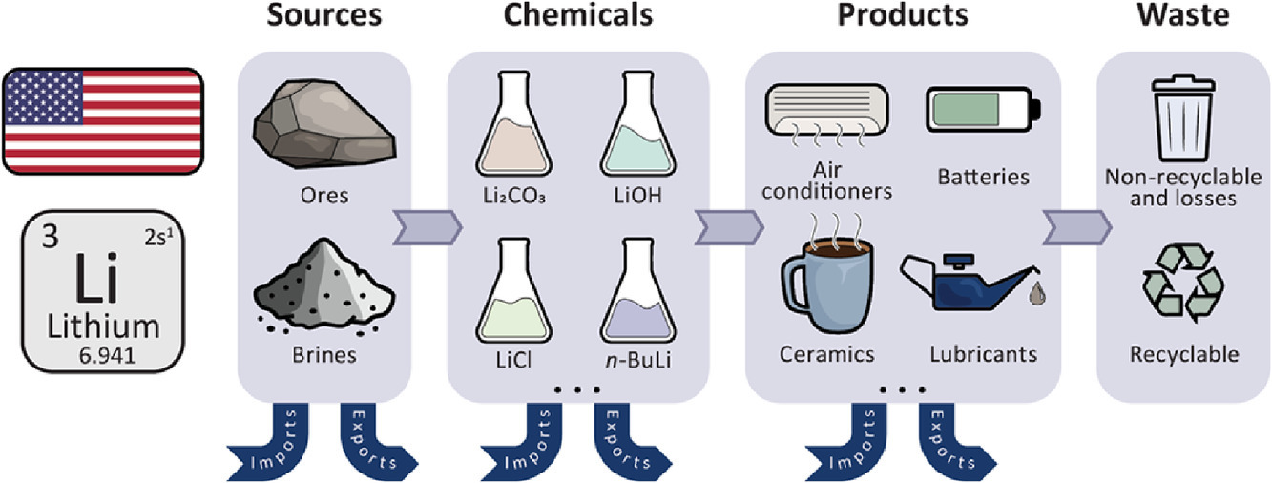

<https://www.electrive.com/2023/09/14/possibly-worlds-largest-lithium-deposits-found-in-the-usa/>

<https://www.instituteforenergyresearch.org/renewable/lithium-mining-in-north-america/>

<https://www.eenews.net/articles/silicon-valley-of-lithium-nevada-mine-breaks-ground/>

<https://www.chemistryworld.com/news/lithium-discovery-in-us-volcano-could-be-biggest-deposit-ever-found/4018032.article>

<https://www.usatoday.com/story/news/investigations/2024/01/26/lithium-mining-affects-water-supply/72344587007/>

<https://www.sciencedirect.com/science/article/pii/S0921344920303517>

<https://www.kunr.org/energy-and-environment/2023-01-10/northern-nevada-thacker-pass-lithium-mine-native-american-western-resistance>

<https://e360.yale.edu/features/lithium-mining-water-andes-argentina>

<https://www.sciencedirect.com/science/article/pii/S2214790X22000983>

<https://www.mining-technology.com/analyst-comment/lithium-mining-negative-environmental-impact/#:~:text=The%20surge%20in%20lithium%20demand,GlobalData%27s%202023%20report%20has%20caused?cf-view>